RANU RAJPUT
Employee Id 1743

JDBC Assignment

Create on Product Table with Schema
Product(pid (pk), price, name)
Cart(pid(fk), qty)
Insert all unique records (put your first name as suffix to each product)
Find out the total price to be paid at the time of check out.
The example data shown should be changed in before being inserted into the table. e.g.
If your name is "Akash" then product table entries should be like below:
(pid -> 1, pname -> "Reynolds 405_Akash", price-> 8)
You can use MySQL console to insert data into the table.
Use JDBC API to Make a query.

Creating database and tables by using MySQL-->

Create database Shopping;

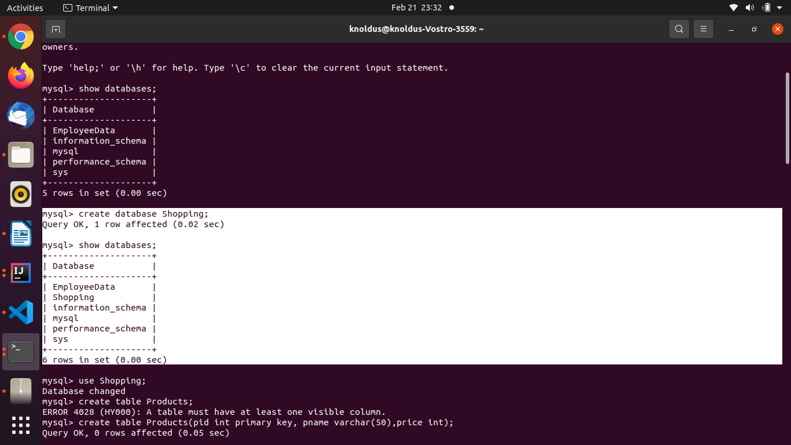
Enter into database Shopping using use Shopping ;

create table Products(pid int primary key, pname varchar(50),price int);

for products table structure-->
desc Products;

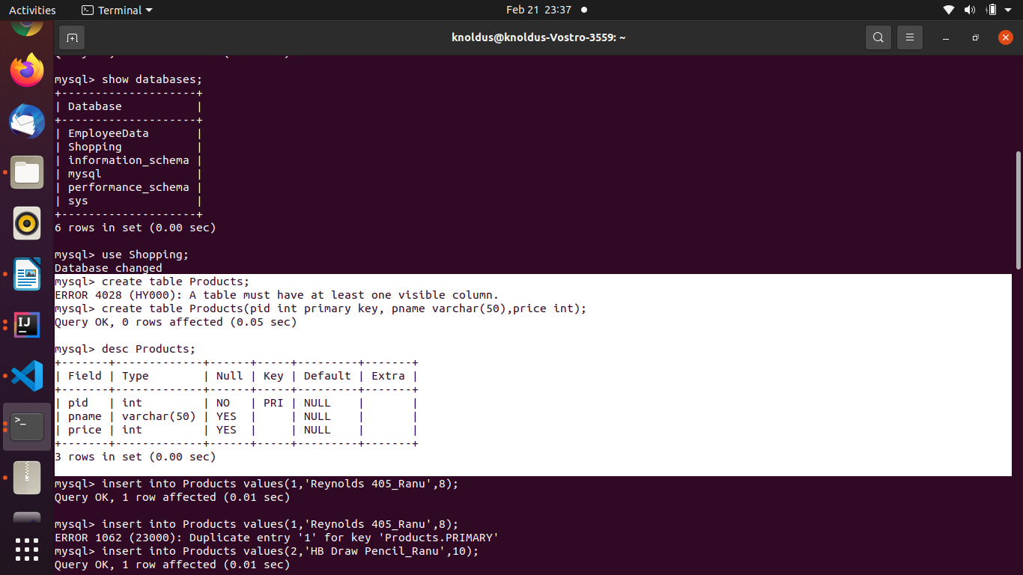

Insert values in Products table ,
insert into Products values(1,'Reynolds 405_Ranu',8);
insert into Products values(2,'HB Draw Pencil_Ranu',10);
insert into Products values(3,'Crayons Rainbow_Ranu',12);
insert into Products values(4,'Notebook_Ranu',14);
insert into Products values(5,'DrawSheets_Ranu',16);
insert into Products values(6,'Brush Air_Ranu',5);

for Products table -->
select * from Products;
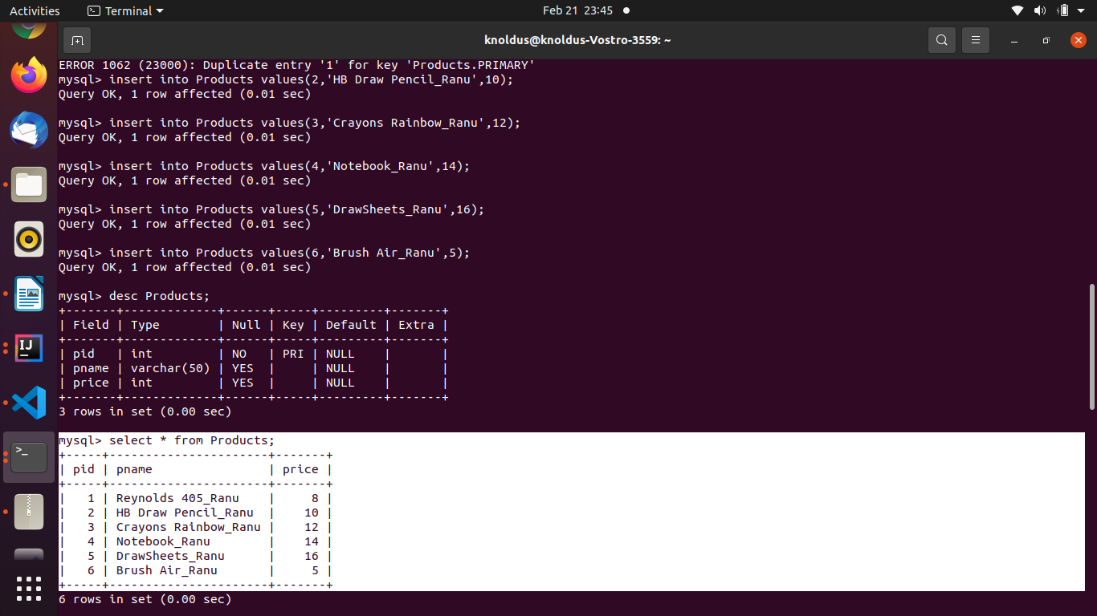
Creating cart table -->
create table Cart(pid int, qty int, constraint fk_Products FOREIGN KEY (pid) REFERENCES Products(pid));

for structure of cart table -->
desc Cart;

for inserting values into Cart table -->
insert into Cart values(1,2);
insert into Cart values(2,3);
insert into Cart values(3,5);

for showing Cart table -->
Select * from Cart;

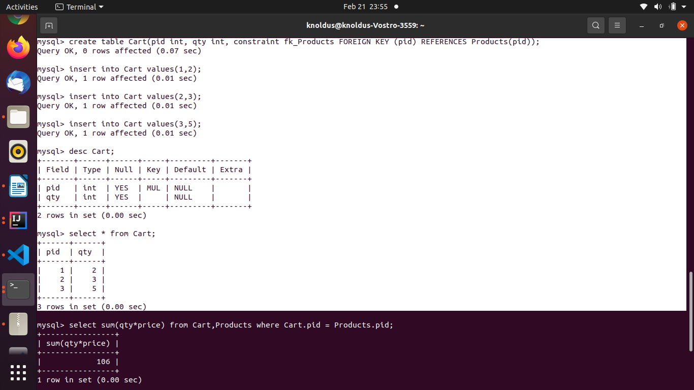

apply another query -->
select sum(qty*price) from Cart,Products where Cart.pid = Products.pid;
